Give Thanks
On November 20 2020 President Russell M. Nelson committed the world to having and showing more gratitude. President Nelson promised that gratitude would be the means by which people could find healing and survival in the days ahead.
On November 20 2020 President Nelson’s application of his message was almost entirely that of social media. Although I whole heartedly agreed with the message and the message’s authenticity of divine revelation, I worried about the application of it. On the same day I posted and said that I hoped members would take the time to show gratitude for things of a divine nature that unify and heal and not take the time to openly virtue signal and share things publicly that either A. shouldn’t be shared publicly or B. that would cause more division and hatred.
For example, my wife struggled with infertility. There are many married women who have suffered for years and years with miscarriages. Openly proclaiming your thanks to God for having children is a wound opener for infertile individuals. Does this mean that you can’t be thankful? The answer is no. We are entering a time period that perfectly describes this phenomena.
Does every family get a Christmas tree? Does every family get a bunch of presents? Does every family get a new Xbox? Does every family get that big turkey dinner? Christmas has the highest suicide rates of the year. And the reason? Because people feel alone, forgotten, looked over, robbed of experiences, and those that are enjoying those experiences are more interested in gloating and sharing to the world how blessed they are versus reaching out to those less fortunate and lifting them up.
So, am I saying don’t be grateful and don’t show that gratitude? No. Am I saying don’t shower your parents with praise when they have spoiled you? No. What I am saying is that you shouldn’t go up the street and rub little Johnny’s nose in the fact that you got an Xbox and he got socks. What does the Lord want us to do? The Lord wants us to pray unto Him in secret in gratitude and then get up from that prayer and go off into the world and show that gratitude by our actions.
There were some members who were upset at me for suggesting this, conflating a lack of faith in the prophetic keys with our application of revelation from on high. I know that the Lord told President Nelson that gratitude was the key to healing and surviving the days ahead, and I know that as we express our gratitude to the Savior and our Father in Heaven in fasting and prayer and then show the Lord that gratitude by our actions we will find healing and strength.
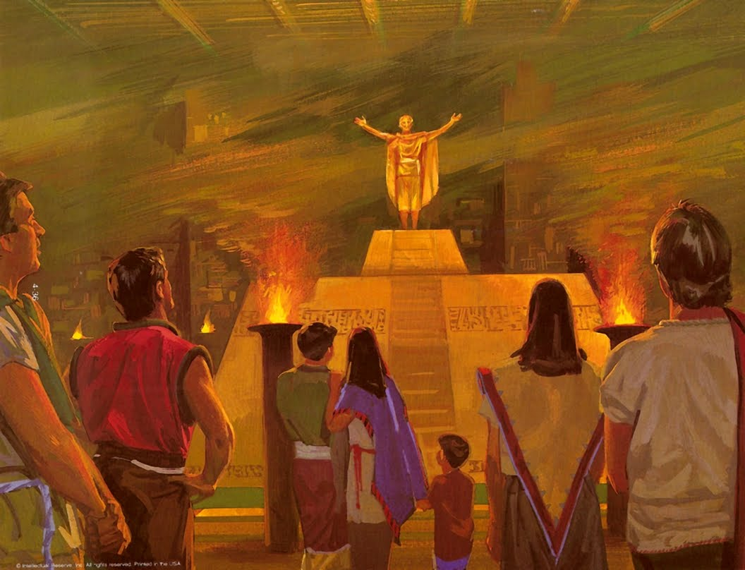
But I also know that the Lord did not and will not ever tell the Saints to go hand in hand with Babylon and with the wicked. The Lord did not and will not tell the Saints to get on the rameumptom and virtue signal and then get off that rameumptom and do nothing throughout the week. That is literally the opposite of what we are supposed to do. We are to declare our thanks privately and work out our salvation openly throughout the week; which is the opposite of declaring our worthiness and thankfulness openly and spending the rest of the week in your closet.
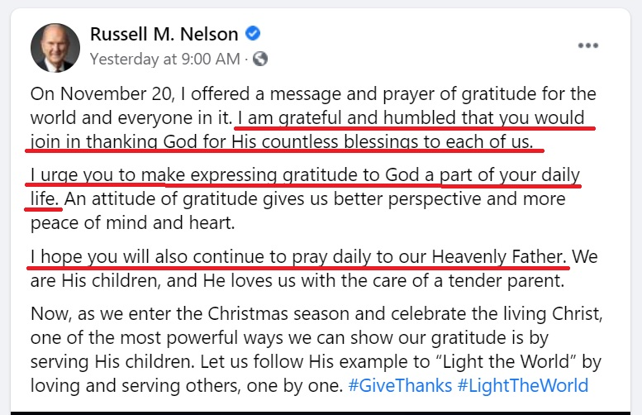
After taking the heat that I did, President Nelson on November 29 2020 sent out this update to his commitment which was a 180 degree change in focus, or in other words, the application of his revelation. In it President Nelson mentions social media a grand total of zero times.
He said, “I am grateful and humbled that you would join in thanking God for His countless blessings to each of us…I urge you to make expressing gratitude to God a part of your daily life….I hope you will also continue to pray daily to our Heavenly Father.”
End Quote
Thanking God for blessings that you have received couldn’t be more different from standing on rameumptoms and professing gratitude to the world.
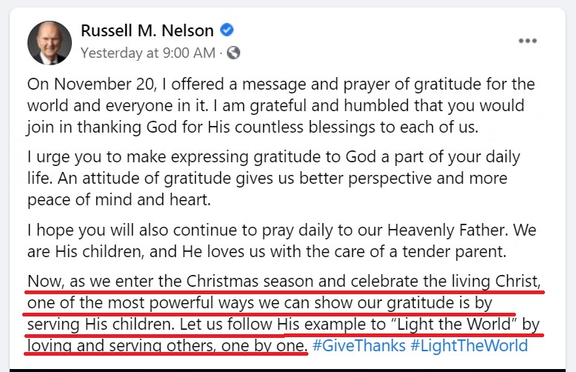
President Nelson continued in his updated message,
“Now, as we enter the Christmas season and celebrate the living Christ, one of the most powerful ways we can show our gratitude is by serving His children. Let us follow His example to “Light the World” by loving and serving others, one by one.”
End Quote
This is exactly what I said that application should be, and for which I took heat for. I hope and pray that the same people who got upset at me will apologize. This is how we implement it. Gratitude to God and our actions in the form of service and lifting of our brothers and sisters.
Fasting and praying in gratitude this last week has been a unique experience that has caused me to reach certain conclusions and understandings that I haven’t thought of or reached in the past. Anybody who has read my Agency in Progression papers know that I suggested holding monthly fasts of gratitude, which I try to do. However, this one was different in that I came to a different understanding that I have not had previous in my life.
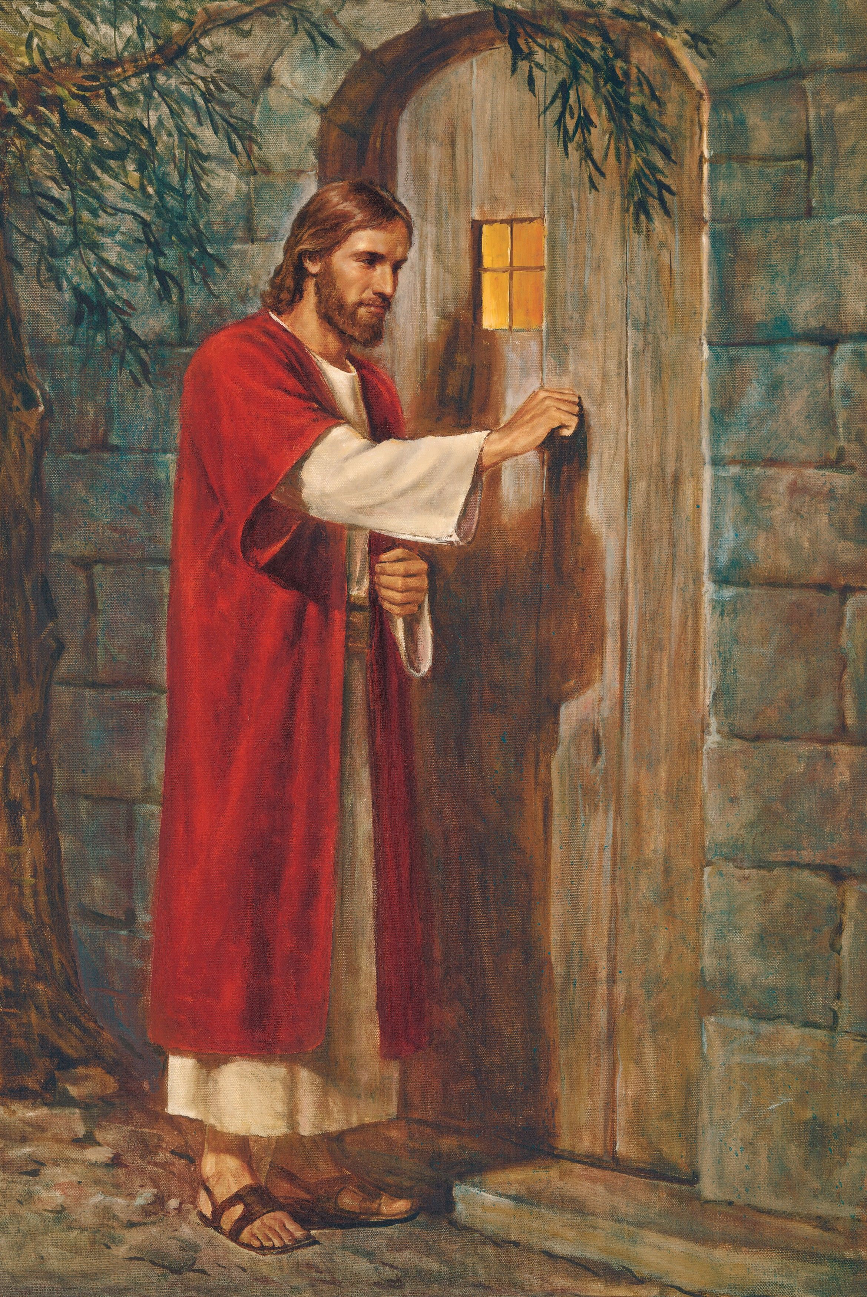
I have always had a relationship with Jesus; I’ve always felt like somewhere deep inside of me that I know him and I can honestly say, although it might sound cliché it is the most accurate way of expressing how I feel, and that is to say that I have always felt as though Jesus Christ was and is the best friend I have ever had. When I feel alone, I always feel Him reaching out to me. When I make mistakes I always feel Him pull me back. When I push away and get upset He always knows what to do to change my heart. I know that He is real. Thinking about this and last day timelines, my mind caught hold on the tests ahead, the tribulations, the anti-Christ.
In the LDS New Testament student manual we read,
Revelation 13:11–17. A Second Beast “Spake as a Dragon”
Revelation 13:11 tells of a second beast that John saw; he later identified this beast as “the false prophet” (Revelation 19:20). This second beast “had two horns like a lamb” but “spake as a dragon” (Revelation 13:11). This description suggests that the second beast will seek to appear to represent Christ while actually teaching the false doctrines of Satan. The description of the second beast is also reminiscent of the Savior’s warning to “beware of false prophets, which come to you in sheep’s clothing, but inwardly they are ravening wolves” (Matthew 7:15).
In the Bible Dictionary we read of the anti-Christ:
“A word used by John to describe one who would assume the guise of Christ, but in reality would be opposed to Christ. In a broader sense it is anyone or anything that counterfeits the true gospel or plan of salvation and that openly or secretly is set up in opposition to Christ.”
The Muslims teach in the last days their 13th Imam or prophet will appear and will have with him Jesus Christ who will be a Muslim. This apparent “Jesus Christ” will teach that he is not the son of God and that he never died for mankind, and that all need to convert and accept this doctrine or they will be killed. The Muslims also teach that people can avoid this death by wearing a shahada and paying tribute.
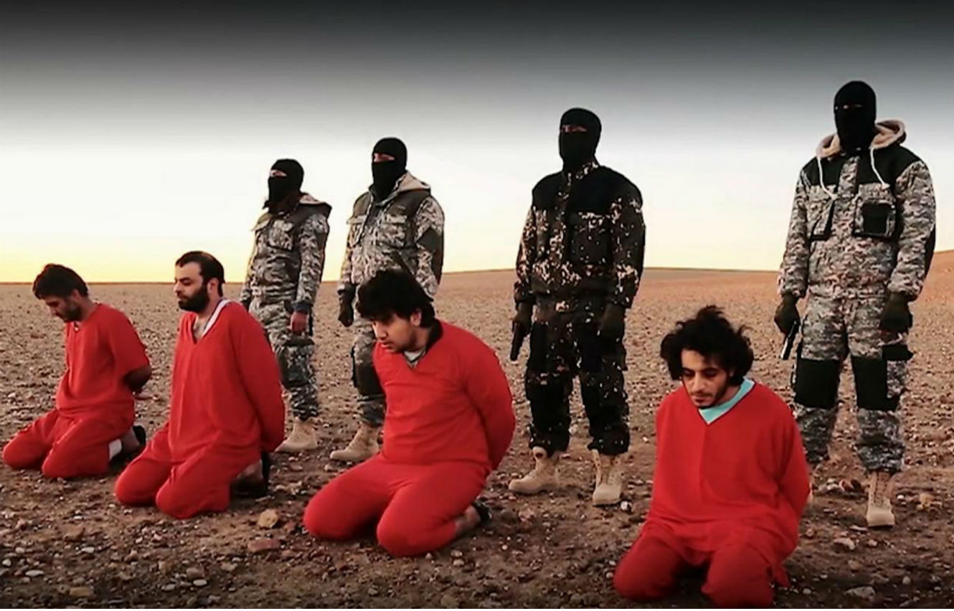
It’s obvious to think of reason of why people would, in fear, deny Jesus. Fear of death is a powerful thing and when presented with that trial those who have not mentally made the choice beforehand will be much more prone to fail.
But the scriptures teach that fear is not the only tool in his arsenal. It says that the false prophet, the anti-Christ, will “deceive many” and convince many because of the power that he is able to manifest, in calling fire down from heaven, changing time etc. This is when my realization occurred.
If someone showed up and presented evidence, proof, miracles, that Jesus wasn’t the Christ or that Jesus wasn’t the Savior of the world, would I accept that? What if everything I was seeing and everything that I was being taught seemed 100% factual, what would I do? And this is when I reached a new understanding of just how grateful I am for the Savior, for Jesus Christ the man. If the choice was presented to me to live but in a universe without Jesus as I understand him, without the relationship that I have with him, or to die and risk being wrong and never being resurrected again, I would rather be wrong and die and cease to exist than to live in a universe without my Savior. I can’t even imagine how different my life would be without the relationship that I have with him. The realization that I reached is that this is life eternal to know thee the Father and Christ whom thou hast sent. Without that relationship, without that knowledge, life literally has no meaning- it becomes a dark, lonely and cruel existence.
Coming to this realization was bitter sweet. Knowing that there are and will be those who choose a life without purpose or meaning or value over that of the Savior is heartbreaking. How often would the Lord have gathered us and put us under his protective wings but we would not?
The other bitterness that I tasted was that of my own ingratitude. Coming to this realization in the way that I did brought also to my realization just how much I have taken that relationship for granted most of my life. I have known he is there, I know His arms are lengthened the whole day feeling after us. And how often do I take advantage of that in a negative way? How often do I take it for granted and treat it as a given or a thing of naught? Being raised in the Church and coming to an early understanding of the truthfulness of it, I have been spoiled like that.
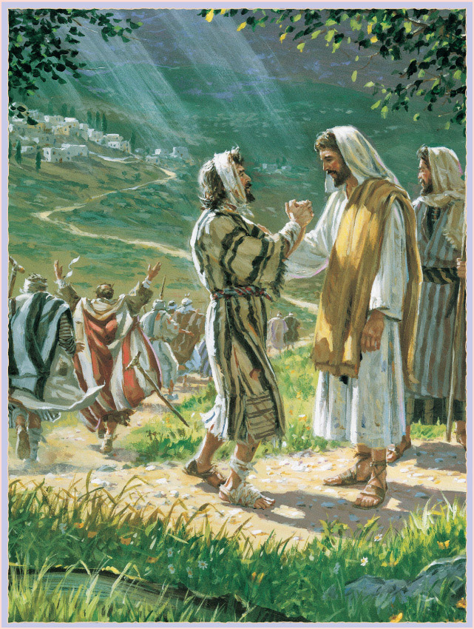
Gratitude always leads to action. If we are grateful for the Savior, if you love Him, according to the Savior “you will keep his commandments”. The Savior said on another occasion “ye are my friends if you do whatsoever I command you”- simply put, you are my friend if you follow me. There are many who teach the false doctrine that the Lord accepts you, that the Lord will be your friend regardless of your actions. The reason why this is so damning is much like communism, when you steal money to give to another person it robs the first party of giving the gift and it robs the second party of gratitude. This doctrine robs the Lord’s agency, or his choice or ability to give the gift- it is forced- and it robs the individual of gratitude which is shown in their actions. How do we know that one of the lepers was grateful? How do we know? And why do we teach that nine were ungrateful? How do we know that or how do we judge that? By their actions. The one returned and fell at the feet of the Savior. If their actions didn’t matter, why did the Lord ask where the other nine were?
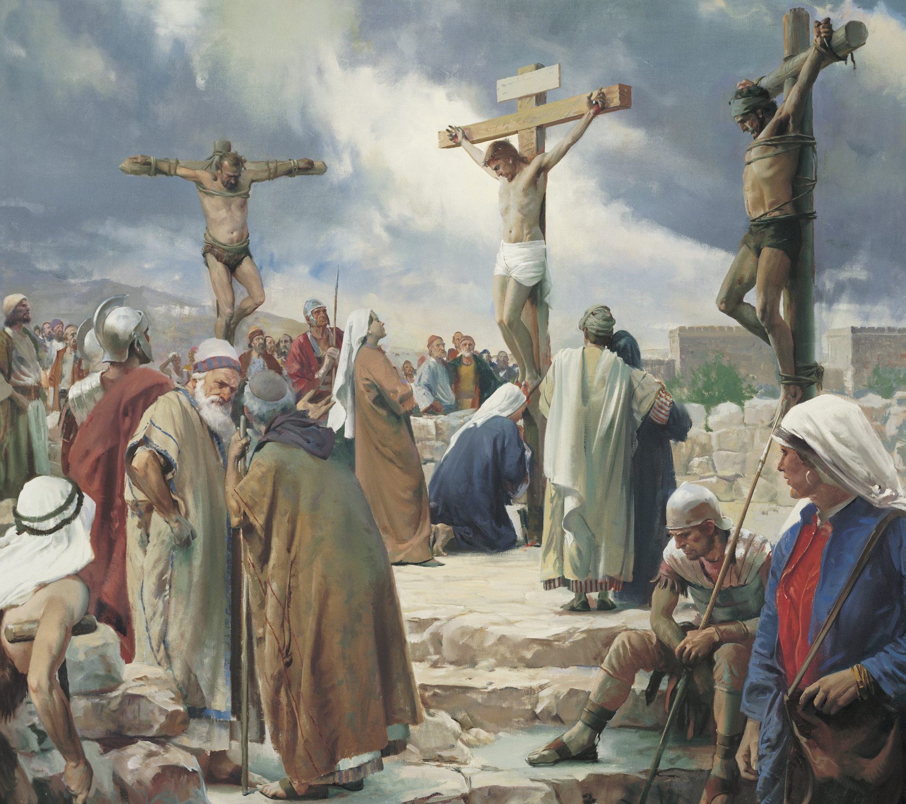
How often in my life was I part of the nine? I might have known the Savior, I might have been “healed of leprosy” by Him, but did I return and fall at His feet? Did I show Him my gratitude by my actions?
I am eternally grateful for the Savior and the relationship I have with Him. I know that if I work as hard as I can for the rest of my days I will still be an unprofitable servant. I am grateful for a Savior that despite me being an unprofitable servant he sees value in me and has taken the time to refine me in fire. I pray that we can all gain a real relationship with the Savior and then show that gratitude by our actions for the time to prepare for the Second Coming is running out, and those who do not have that personal relationship with the Savior will not make it.
And what better time for us to show that gratitude and reach that relationship than at this time of year. This time of year in which we celebrate and try in some small way to understand the condescension of the Lord Jesus Christ to the earth. I am eternally grateful and will forever be indebted to the Savior for leaving the courts above and walking the dusty roads below to satisfy the demands of justice and provide a way in which mankind could be redeemed. I hear promise and commit myself to making this Christmas reflect that and not that of materialism and pagan rituals and traditions, and commit all of you to do the same. May we truly show by word and deed this Christmas season that we won’t allow a sniffle to come between us and the Christmas spirit which is the spirit and light of Christ. In the name of Jesus Christ, Amen.

